BioBed – A biological Latrine System for
Sustainable Peri-Urban Sanitation
Faecal sludge reduction in pit latrines through the use of
Black Soldier Fly larvae
z
z
Z D
z
z
Z D

z
z
Z D

z
z
Z D

z
z

Z D

Annemarieke Mooijman Consulting (Netherlands)
with
LCS Promotion Int (Sweden) AB

revised version, March 2016

Table of Contents
1. Background of the Application 4
The Idea 4
Urban sanitation in Maputo 4
Strategies 5
The BioBed approach 5
BSF larvae application scenarios applied under the project 6
Applying organisations 6
Project location 7
Scientific sources 7
Related initiatives 8
2. Project components 10
BioBed Latrines 10
Marketing and socio-economic acceptability 13
Monitoring and documentation 16
3. Workplan 18
Year 1 – Research and prototype development 18
Year 2 – Piloting, assessment of socio-economic acceptance and training of entrepreneurs 19
Year 3 - Scaling up and marketing 19
Outcomes 20
4. Organizational set-up 21
The Project Implementation Model 22
22
5. Budget indication and break down of subsidy request of the VIA Water Fund 23
6. Annex 26
Info on Annemarieke Mooijman Consulting, Netherlands 26
Info on LCS Promotion Int (Sweden) AB 27
Info on BizzDev EI 28

Background of the Application
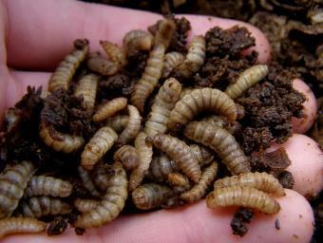
Black Soldier Fly (BSF) Larvae
picture http://michaelcmichaeldo.com/blog/wp-content/uploads/2013/07/bsgrubs.jpg

The Idea
The starting point of this project is to convert existing and/or new latrines from being traditional pits for accumulation of faecal matter to small on-site sludge treatment stations where the faecal sludge is converted to CO₂ and to seepage water which can be infiltrated (or used for control of pest flies). According to recent research Black Soldier Fly (BSF) Larvae can convert fresh human faecal matter in latrines to “water and carbon dioxide” with reduced environmental risks and substantial long term savings. Using the right techniques this is also accessible and affordable to the lowest income groups, especially in urban areas.
The heart of the sanitation crisis lays in the high-density peri-urban areas.

Urban sanitation in Maputo
The lack of access to improved sanitation is even more acute in the informal settlements and peri-urban areas of Mozambique's capital Maputo (total population including Matola close to 2 million people producing about 400 ton human excreta daily), resulting in cholera outbreaks, widespread diarrheal disease, parasite infections and high child mortality.

Although over the past decades several urban sanitation expansion initiatives have taken place in Mozambique, in urban areas 58% of the population lack access to improved sanitation facilities of which 13% still uses open defecation. No specific information on Maputo could be found but information from comparable cities in the region, reveals that the households with access to improved sanitation do not or just partially use it. The reasons why they are not used can be divided in three sets:
- Lack of awareness and inadequate change in social norms,
- No/limited pit emptying options,
- Inappropriate choice of technologies and construction errors.

Since about two thirds of Mozambique’s population growth between now and 2050 is estimated to be in urban areas, access to improved sanitation facilities in such areas is set to continue to be a critical challenge.

Strategies
The consequent need is to assess and develop the practical possibilities of marketing sustainable sanitation and mitigate constraints and risks through sludge reduction by Black Soldier Fly larvae consuming the fresh sludge inside the latrine (the BioBed approach), hence:
- Minimising the need for pit emptying etc, including physical contact and,
- Create socio-economic acceptance towards the unconventional approach,
- Develop BioBed for commercial production and marketing,
- Document all steps in the development process as learning and monitoring tool.

The BioBed approach
The proposed BioBed system aims at gradually reducing the sanitation chain to practically nothing.
The BioBed system builds principally on the impressive appetite of a Black Soldier Fly larva that after about a month becomes a pupa and a beautiful black fly that only lives for 8 days. Before that, it has to find a willing mate who after the act will deliver up to 500-900 eggs which, under the right conditions, will produce the same amount of very small larvae (±1 mm) who will eat up to 10 000 times its own weight in about 30 days before it stops eating and becomes a pupa, a cocoon out of which a new Black Soldier Fly will emerge. Being so many and eating so much they have to eat e.g. human excreta or garbage until it becomes “water and carbon dioxide”. The water drains off and the carbon dioxide goes up in the air without leaving any residue. However the BSF larva does not eat woody materials and paper, and not synthetic materials like plastic bags condoms menstruation pads etc. so it is important to not “pollute” the excreta. Combining the BSF culture with other species may therefore be necessary.
More on the design can be found in chapter 2

BSF larvae application scenarios applied under the project
There are three principal scenarios that will be researched under this project:
- Charging (start-up) and recharging confined latrine pits with larvae on a monthly basis,
- Designing the latrine in such a way that the adult flies born in the pit can go out and in while the larvae and the pupae stages are spent in the latrine (spiders can be problem).
- A third scenario is off-site production of BSF eggs for the maintenance of confined BSF latrines where BSFs abstain from mating.

Applying organisations
The Project is a joint initiative of
- Ms. ir. Annemarieke Mooijman (project coordinator) of Annemarieke Mooijman Consulting, Meerssen, Netherlands, Email: ammooijman@gmail.com, a Netherlands-based civil /sanitary/environmental engineer and Water and Sanitation specialist with more than 25 years working experience in all parts of the developing world. with,
- Mr. Björn Brandberg (project supervisor), LCS Promotion (Sweden), Email: Björnbrandberg@gmail.com Björn is a Swedish national based in Mozambique, architect, civil engineer and certified social entrepreneur with more than 35 years of working experience in about 20 developing countries. Björn is a partner of LCS Promotion International AB http://SanPlat.com/, a supply company in Sweden that over the past three decades has triggered the building of some 4-5 million improved latrines, principally in Africa.
Björn and Annemarieke worked together for UNICEF Ghana on the “National WASH in School Standard Guidelines and Implementation Model” in cooperation with Ministry of Education, government and NGO-partners as well as the Frisian Urban Sanitation Programme in Mozambique a nine city programme financed by DGIS (Dutch cooperation) and the Frisian cooperation.
Local project implementation is subcontracted to a Mozambican business development company, BizzDev, who for the implementation of this project will have a management agreement with an experienced sociologist and business development adviser, Eduardo Macuacua, presently employed as the director of CTA (Confederation of Economic Associations in Mozambique) who will undertake the administration and management of the Project as a side activity.

Project location
For the ease of logistics and to limit costs for transportation and lodging as well as tapping into the professional network of the project supervisor, implementation of the project is concentrated to (greater) Maputo.

The targeted experimental area in Maputo is a representative strip crossing three barrios, Maxaquene A, B and C of which Maxaquene A is the most congested and poorest settlement and Maxaquene C the “richest” and best organized. In line with the Diffusion of Innovations theory the experimental implementation will start in Maxaquene C (bordering Avenida V Lenine) and step by step reach the more congested and poorer Maxaquene A (bordering Avenida Acordos de Lusaka).

Scientific sources
The project is based on the following scientific sources:
- Research by Banks, I.J. at London School of Hygiene and Tropical Medicine suggests that of Black Soldier Fly larvae (BSFL) could liquefy faecal matter in latrines and that the reduction of sludge accumulation would be minimal. (Project supported by Bill and Melinda Gates Foundation, Grant ‘Reinventing the Toilet’)
- Anno, K.A. at Biofilcom in Ghana suggests that latrine emptying no longer may be required if we can develop a suitable environment in the latrines and stimulate the Black Soldier Flies to lay their eggs in the latrine and the larvae to survive and thrive there. Urine and occasional overloads should not be a problem. (Project supported by Bill and Melinda Gates Foundation, Grant ‘Reinventing the Toilet’)
- Several internet sources stress the capacity of the Black Soldier Fly larvae to consume soft organic matter (up to 10,000 times its own weight in a few weeks) which increases with increased feeding (faecal load). Further, smell and fly problems may be reduced in a BSF environment and that faecal contamination (e-coli) can be reduced by 95%.
- A number of brands claim that latrines can be treated biologically with different powders containing enzymes and/or bacteria to prevent or delay the filling up. This is questioned by recent research by UNICEF (Cormency, C et al. 2015) claiming that a 5% reduction of the filling up rate is insignificant. The same is claimed by B. Brandberg stating that filling up rates in peri-urban Mozambique and Malawi varied from15 litre per person per year to above 300 litre per person per year, depending critically on tenancy conditions.
- Local traditions claim anecdotally that adding salt to the pit, or a dead animal, as a start-up inoculator, would prolong the expected lifetime of the latrine.

Related initiatives
The project will also draw on the finding of the following activities:
- The Biofil Toilet in Ghana
Developed by the Ghanaian company Biofilcom in 2007, funded by the Bill and Melinda Gates Foundation. The Biofil toilet uses a combination of micro-organisms – tiger worms, black soldier flies, dung beetles, and cockroaches – in a batched tank to process the waste. The by-product is a liquid effluent. The tank is about one by one by two meters large. Biofilcom also designed a micro-flush system that is combined with a hand-washing station and reuses hand-washing grey water for flushing. https://www.biofilcom.org/ The biofil solution is much more expensive and more complicated than BioBed.
At different occasions, both Annemarieke and Björn visited their project in Ghana.
- Research support from London School of Hygiene and Tropical Medicine (LSHTM) and BioCycle, Cape Town
During his PhD-research, Ian Banks from LSHTM has explored the use of BSF larvae in human waste treatment in a project also funded by the Bill and Melinda Gates Foundations. Ian Banks is now involved in a few projects that have emerged from his research including AgriProtein, a company that specializes in “nutrient recycling”.
AgriProtein uses fly larvae fed on abundant waste nutrient sources and has developed and tested a new large scale and sustainable source of natural protein. The nutrient recycling bioconversion process utilizes waste food as raw materials and generates valuable feed components: an insect based protein meal, an extracted fat and a nutrient rich soil conditioner.
A joint venture called the BioCycle focuses on using BSF in the sanitation sector is currently running a pilot in an informal settlement near Cape Town, South Africa. http://www.thebiocycle.com/)
Ian Banks and BioCycle will be involved in the BioBed project as a technical adviser (at distance as well as during a support visit to Maputo). Upon start of the project Annemarieke Mooijman and Björn Brandberg will visit and discuss the BioCycle activities in Cape Town.

Project components

BioBed Latrines
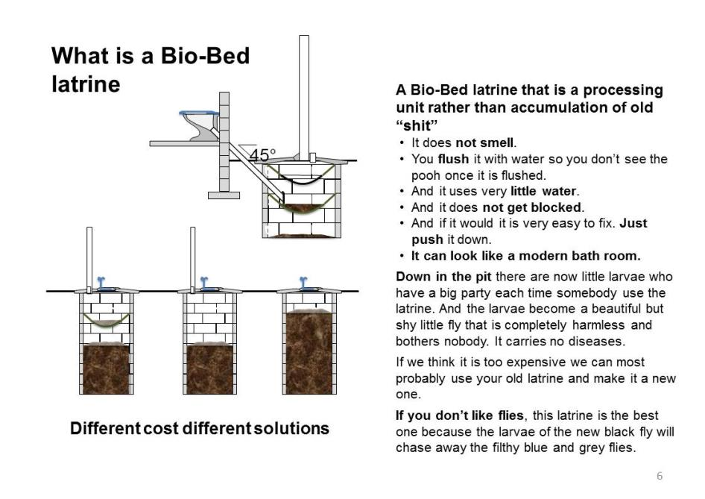
Slide copied from a Power Point presentation by Brandberg as part of the pre-project preparation

The design
The design work is based on integrating (1) the expected socio-economic acceptance of the population in peri-urban communities with (2) the biological conditions required for the BSF larvae to maintain a zero accumulation rate or possibly even lowering the sludge levels on existing latrines. Given the need for light for the BSF mating, lighting, ventilation (oxygen and heat control) and drainage (respiration) hanging biobeds can be introduced in new and existing latrine pits. Vent pipes may consequently be introduced to facilitate this process and make the new ones marketable. Up-market solutions with bucket pour flush and toilet pedestals will be explored.

The project focusses on two marketable designs:
- Transformation of existing (SanPlat) latrines into BioBed system,
- Design of new latrines using BioBed approach.
As mentioned in chapter 1, there are three principal scenarios that will be researched under this project:
- Charging (start-up) and recharging confined latrine pits with larvae on a monthly basis,
- Designing the latrine in such a way that the adult flies born in the pit can go out and in while the larvae and the pupae stages are spent in the latrine (spiders can be problem).
- A third scenario is off-site production of BSF eggs for the maintenance of confined BSF latrines where BSFs abstain from mating.

Existing latrines
The BioBed system at this stage is based on upgrading the Mozambican Latrinas Melhoradas (SanPlat) system . In the first year of the project 40 SanPlat latrines will be converted to BioBed latrines. In the second year an additional 60 SanPlats will be converted. Eventually (in the third year) a transformation kit concept (from SanPlat to BioBed) will be developed with the aim to be produced and sold by LCS Promotion for marketing in all parts of the world.
New latrines
The system will be adapted to simple “long drops” and VIP latrines (see below drawings). In the first year of the project 10 prototypes of new BioBed toilets will be constructed and tested.
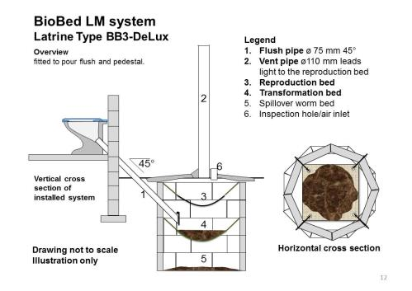 | 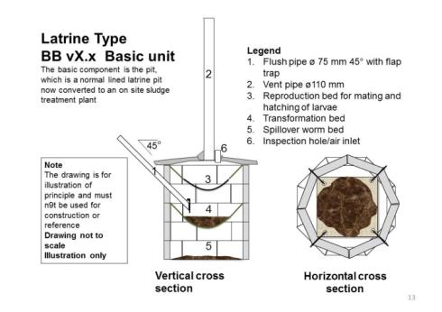
Two initial pilot designs for new toilets (by Björn Brandberg)

Challenges
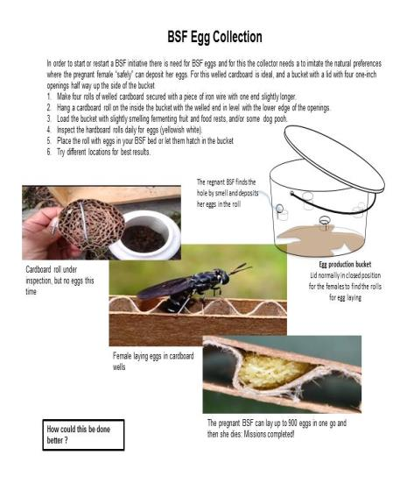 | Fear to introduce 'exotes'?  BSF live "all over the world" including the US and definitively the tropical countries. It is generally considered a blessing with fantastic potentials of which sanitation is a new one.  The flies used are free flying local BSFs 'collected' locally. The reason why people are not aware of the BSF flies is because it is completely uninterested in people. It lives as a fly only for 5-8 days for mating and egg production. It does not eat because it has no mouth but lives on what it has been eating and accumulated as larva.  With the larva the situation is radically different because it eats human faecal matter which contains a lot of germs but in the new latrines the faecal matter stays in the pit to undergo a 95% reduction of E-coli.(!) Super safe if compared with manual pit emptying and uncontrolled disposal of the pit contents in the human environment.

Flies bother people?
BSFs are not interested in people and do not carry diseases, but are effective cleaners of nature providing high value protein and energy to “higher” animals. The proposed system imitates nature and complementary organisms may be introduced like earthworms, fungi and soil bacteria. Cockroaches will naturally find their ways into any latrine. Though they are harmless for the BSF larvae, they are disliked by people and may transmit disease. The same applies for blue bottle flies that normally infest latrines. Various sources clam that a BSF colony will repel these flies and also render the latrine free from these unwanted flies. The BSF larvae may also turn a latrine free from smell, and it reduces the e-coli by 95% with a corresponding reduction of the risk for pollution of the ground water.

Design latrines adapted to the biological requirements of the life cycle of the BSF.
If successful, the latrine pit could become a micro treatment station for final treatment and elimination of dangerous faecal sludge rather than a pit for accumulation of faecal sludge. This would eliminate the need for latrines to be emptied, sludge liquefied and transported to a (non-existent) place for treatment or discharge, presently with serious environmental risks. An alternative is especially urgent for high density areas where there is no place (or money) for building replacement latrines. Instead people have no alternative than to dispose their excrements in the municipal waste heaps, where it will be spread by wind, rain, flies, rats, cats, dogs and marginalized people looking for something to eat.
Construction costs for the new latrines could be low, even below the construction cost of a normal latrine to make them attractive for low income people in peri-urban areas and for a market to be developed.

Marketing and socio-economic acceptability
Putting private sector at the right spot in
The project has been inspired by Mariana Mazzucato´s: The Entrepreneurial State: debunking public vs. private sector myths where she explains that most of the innovations worldwide were invented through publicly financed research where private sector used its marketing techniques to take it up and make it profitable.
Keeping this in mind, the first year of the project will be financed by the ViaWater funds and the project team´s own resources and gradually in the following years more and more private financing will be involved when the marketing aspect becomes prominent.
Marketing of the Bio-Beds ensures that people choose to receive what they want and are willing to pay for, the product is financially sustainable, cost-effective and can be taken to scale.
Marketing is often said to have four components, the four Ps; product, price, place and promotion. For social projects a fifth P, Policy, need to be added. Specifically for BioBed this means:
- Product: Because of the expected demand for BioBed latrines, supply lines can only be sustained with support of private sector entrepreneurs who are willing to invest (and earn) from the technology. For this purpose special attention will be given to cost savings and local availability of critical products. Under the project 20 entrepreneurs can apply to be trained on BioBed construction and sanitation marketing.
Further the project will develop a transformation kit concept “from SanPlat to BioBed” to be brought to scale by LCS Promotion, possibly in cooperation with local businessmen.
- Price: The Project focuses on low-cost solutions to make BioBed marketable. The price is between the contractor and its clients. There will consequently not be any price control but trainings will be tailored to create competition while still making profit.
- Promotion: The project starts with max. 20 innovative entrepreneurs who are interested to include the BioBed latrines in their product range. Assuming that the demand eventually will exceed their capacity they should be encouraged to train and sub-contract the construction activity to local builders but maintain the BSF production to themselves as a small-scale industry. A growing cadre of contractors and sub-contractors will therefore not only be trained in the technology but also in sanitation marketing.
On a larger scale the transformation kits “from SanPlat to BioBed” will be marketed by LCS Promotion.
- Place: Entrepreneurs will be trained in the importance of meeting the client where business is possible and how to expose themselves at the right time at the right place and combine this with the above mentioned marketing skills. For example looking for urban areas of high density where latrine emptying and construction of replacement latrines is difficult or even very difficult and people are willing to pay for this.
- Policy: will eventually be added to support the programme in the later phases but only when it is well accepted by a majority of the targeted population. This is not expected to happen within the three years of the project but should be kept in mind at all stages and may be tested in interested communities of groups of households. The risk of early introduction of a policy is that training and supervision capacity will be insufficient causing resistance and lost sustainability.

Contracting sustainable sanitation services
Given the assumed/suspected need for regular maintenance of the BSF cultures, provision of BioBed latrines should be made on contract basis where the entrepreneur assumes the full responsibility for construction and maintenance against a sustainable market adapted fee.
The project commits itself to assist to the selection training and monitoring (both technical and in marketing) of up to 20 entrepreneurs with businesses in the peri-urban areas. Beyond this the contractors would need to assume the full responsibility on their own.
In order to secure sustainable operation the implementation will, from the onset and onwards, be applying commercial principles where profitmaking, at all levels, is seen as a success criterion rather than a limiting conflict of interest.

Socio-Economic acceptability of BioBed
The proposed introduction of the BioBed system (sustainable and inclusive sanitation) is based on the Diffusion of Innovation theory. It was determined that about 2.5% of the population are innovators who will adopt an idea after adapting it to local conditions and possibilities. The innovators would be followed by a second group, the early adopters, also called the EER group, the Educated, Employed and the Relatively Rich (±13.5%), making a total of ±16%. Together they form a critical mass after which the initiative has reached its own momentum. Considering the innovative nature of BioBed as well as the challenge of socio-economic acceptability, the project will focus on the 16% accepting the proposed unconventional approach gradually approaching full coverage of sustainable sanitation.

Monitoring and documentation
Innovation, monitoring and documenting go hand-in-hand. Innovation is a learning process which needs an analytical view, mapping and reflection on what has been achieved, what worked and what did not work, who were the key actors, what were their roles and what was the enabling environment to make this work. Monitoring and documenting are key to this learning process because it allows for a step-by-step and analytical overview on what happened.
The project aims for an efficient, cost-effective way to make sure that the monitoring is relevant, and not too much or too few data are being collected. Therefore at the start simple, operational, measurable indicators will be formulated. As much as possible the monitoring will be undertaken by partners and beneficiaries of the project as part of their daily/weekly/monthly routine, in order to notice changes or deviations from the expected.
The documentation consists of the publication of the findings from the monitoring activities through articles and a blog as well as every 6 months a project progress update and workplan.
The methodology for monitoring and documentation is based on, but not limited to, the following data collection methods and tools:
For the baseline survey:
- A simple household survey of beneficiary households as well as a brief interview on habits and conditions (specified on specific groups as women, elder people, children etc.).
- Photo/video information collection on existing situations.

For the monitoring system:
Given the innovative character of the project, emphasis will be given principally to qualitative data collection.
- Photo/video information collection on existing and changing situations (if possible also by beneficiaries).
- Logbook recording beneficiary points of view and possibility to report problems to the locally recruited sociologist.
- Focus groups assessments with beneficiary households.
- Implementation reporting.

For evaluation
The principal evaluation criteria are sustainable function, demand creation, replicability and inclusiveness.
- Beneficiary household survey using questionnaires.
- Focus groups with beneficiary households.
- Photo/video information collection on existing and changing situations by the project architect, contractors and sociologist (and if possible by beneficiaries).
- Logbook recording of beneficiary/households opinions with possibility to report problems to the project team.

The analysis of the Monitoring data will focus on:
- Interpretation of data (including double check),
- Judgement (assessment of findings, assessing positive and negative aspects of findings),
- Formulation of recommendations,
- Presentation of findings in a user-friendly way (differentiated for the different the users).
The analysed data and findings will be used to identify problems and possibilities and to take corrective programmatic measures if needed, but also for PR and justification for e.g. additional fund applications.

Workplan
The Project will cover a period of 3 years:
- The first year will focus on research and prototype development,
- The second year will focus on piloting, assessment of socio-economic acceptance and training of entrepreneurs,
- The third year will be used for scaling-up and marketing.

Given the innovative character of the project and that that there are no earlier experiences of the BioBed sanitation system in Mozambique (or elsewhere) the implementation of the year 2 and 3 programme is subject to successful outcome of year one.
During the project period there will be documentation (through articles and a blog on the progress and findings) of the activities, successes, failures and findings in all phases of the project implementation.

Year 1 – Research and prototype development
Year one is a design and experimental year aiming at assessing the viability of the BioBed idea to build and maintain sustainable latrines:
- Ongoing internet research (with support from LSHTM),
- Design and testing of a small-scale BSF cage where a BSF colony is started by “inviting” pregnant BSFs by posing egg collectors at strategic places and let them hatch inside the cage,
- Tentative design of technical options to understand function and the aspirations of the different client categories,
- Experimental construction of 10 prototypes and conversion of 40 SanPlat latrines to BioBed in a strip crossing the Maxaquene Bairros C, B and A of Maputo,
- Training of 2-3 entrepreneurs,
- Setting-up a monitoring and evaluation system, Experimental implementation,
- Documentation (through written articles and a blog on the progress) of the activities, successes, failures and findings in all phases of the project implementation.

Year 2 – Piloting, assessment of socio-economic acceptance and training of entrepreneurs
The objective of the piloting phase is to assess possibilities and constraints for the expansion of the BioBed approach:
- Pilot implementation to test the findings in a real setting (60 SanPlat conversions) in a strip crossing the Maxaquene Bairros C, B and A of Maputo while entrepreneurs market more BioBed latrines in areas of their own choice.
- Discuss technical and socio-economic acceptance and potential strategies with humanitarian and development organizations, private sector, universities etc. in Maputo and beyond,
- Promotion of the project with possibility for up to 20 social entrepreneurs to apply for participation; Selection of social entrepreneurs, training and testing, support (both technical and in marketing), support to setting-up businesses,
- Participatory assessment of user and acceptance aspects with potential consumers/users,
- Documentation (through written articles and a Facebook blog on the progress) of the activities, successes, failures and findings in all phases of the project implementation.

Year 3 - Scaling up and marketing
The third year is for assessing the possibilities of wide scale promotion and policy development:
- Modifications and further development as required (in design and marketing),
- Development of transformation kit concept (from SanPlat to BioBed) for large scale application,
- Scaling up the experiences from the pilot phase in order to understand possibilities and constraints of a rollout programme,
- Documentation (through written articles and a Facebook blog on the progress) of the activities, successes, failures and findings in all phases of the project implementation,
- Draft policy development (depending on the outcomes of the project).

Outcomes
The project is an innovative project which on request of ViaWater has been split up in two funding phases.
The first year focuses on research and prototype development. The outcomes of the first year will be:
- App. 10 prototypes and test models functioning as well as the upgrade and functioning of 40 Sanplats to BioBed,
- Functioning Monitoring and Documentation system,
- BSF larvae production secured through functioning BSF cages,
- 2-3 entrepreneurs trained,
- Written and published progress documents.

The second year focuses on piloting, assessment of socio-economic acceptance and training of entrepreneurs. The outcomes of the second year will be:
- The upgrading and functioning of 60 Sanplats to BioBed as well as the construction of BioBed latrines through entrepreneurs,
- Technical and socio-economic acceptance and potential strategies agreed upon in full consultation with all stakeholders,
- Max. 20 entrepreneurs trained,
- Written and published progress documents.

The third year focuses on scaling-up and marketing. The outcomes of the third year will be:
- Marketable BioBed designs and strategies developed to allow for scaling-up and sustainability,
- A transformation kit (from SanPlat to BioBed) to be produced and sold by LCS Promotion,
- Scaling up the experiences from the pilot phase in order to understand possibilities and constraints of a rollout programme,
- Draft policy development (depending on the outcomes of the project).
- Written and published progress documents.

Based on the findings of Ian John Banks’ PhD thesis at London School of Hygiene and Tropical Medicine and experimental findings by BioFill (Ghana 2015) the larva of the Black Soldier Fly (BSF)
Joint Monitoring Programme Water and Sanitation 2015 UNICEF/WHO
BioBed is a name created for the use in the context of this project
See Marketing part in chapter 2
Banks, IJ (2014) To assess the impact of black soldier fly (Hermetia illucens) larvae on fecal reduction in pit latrines. Doctoral thesis, London School of Hygiene & Tropical Medicine. Downloaded from: http://researchonline.lshtm.ac.uk/1917781/
Brandberg, Info from Anno Nov 2015
Banks, IJ (2014) To assess the impact of black soldier fly (Hermetia illucens) larvae on faecal reduction in pit latrines. Doctoral thesis, London School of Hygiene & Tropical Medicine.
The use of conventional flush water toilets will not be encouraged since they might turn the system anaerobic (like a septic tank). Water is also turning itself into a scares resource in urban areas in Mozambique, due to climatic change and urban growth.
Björn Brandberg has been involved with the design and marketing of SanPlat latrines since 1979. About 500 000 dome-shaped have been built in Mozambique most of which as private sector spin off production. Mozambican dome-shaped latrines can be found all over peri-urban areas in Africa.
http://marianamazzucato.com/
As developed by E. Rogers et al (1963) which in turn was based on the analysis of 508 diffusions projects, today quoted in over 23 000 scholarly papers.
Edison, the inventor of the light bulb claimed to have failed 1000 times before he managed to keep it burning. After each failure he had claimed to have discovered a way that did not work.
To be confirmed

